CST 238 Lab 4

Tile Puzzle

For this lab, you will create a GUI version of the classic tile puzzle pictured below:

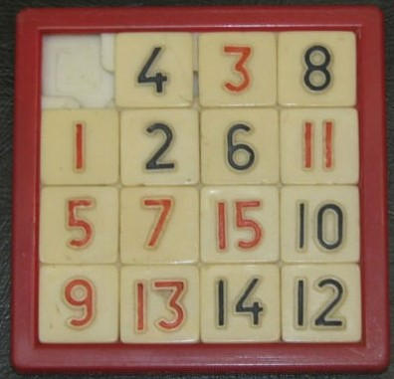

Users can move a tile by clicking on a tile next to the missing one. The clicked tile will move to the open space. The goal is to get all the tiles in the correct order 1..4 in the first row, etc.

You have your choice of the following development mechanisms:

1. Hand coded Java GUI (such as Labs 1,2)
2. QT Designer build C++ GUI (such as Lab 3)
3. Hand coded QT C++ GUI (such as we talked about on Friday)

I have supplied both a C++ and Java implementation of the game logic. You must keep the game logic separate from your GUI implementation. You can either use my implementations, modify them, or write your own, as long as you keep the game logic separate from the GUI.

Minimum requirements:

1. 4x4 game
2. Menu that can re-scramble the tiles
3. Something better than default appearance of buttons, frame, window, etc.
4. Some way to indicate invalid operations. Your mechanism must be intuitive, and not interfere with the flow of the game. For example, popping up a dialog box that the use has to click OK in is a bad idea because that would interfere with the flow of the game. Note: the game logic has a callback mechanism you can use. You don’t need to do your own error checking.

Enhancements (extra credit):

1. Menu that allows you to select the size of the game.
2. Turn counter: records how many moves you’ve made since the last scramble.
3. Enhanced appearance
4. Something other than numbers on the tiles.